SUnday | Monday | Tuesday | Wednesday | Thursday | Friday | Saturday
 |  |  |  |  | 1 | 2
3 | 4 | 5 | 6 | 7 | 8 | 9
10 | 11 | 12 | 13 | 14 | 15 | 16
17 | 18 | 19 | 20 | 21 | 22 | 23
24 | 25 | 26 | 27 | 28 | 29 | 30
31
2010
JAN

OUR FAMILY CALENDAR

DAD’S EVENTS | DATE
PARENTS’ ANNIVERSARY | JAN 1
Out of Town CONFERENCE | JAN 15-18

mom’s EVENTS | DATE
Doctor’s Appointment | Jan 7

Maile’s Events | Date
Dance Recital | Jan 11
Sign Up, Swim Lessons | Jan 13
Field Trip | Jan 29

TO DO
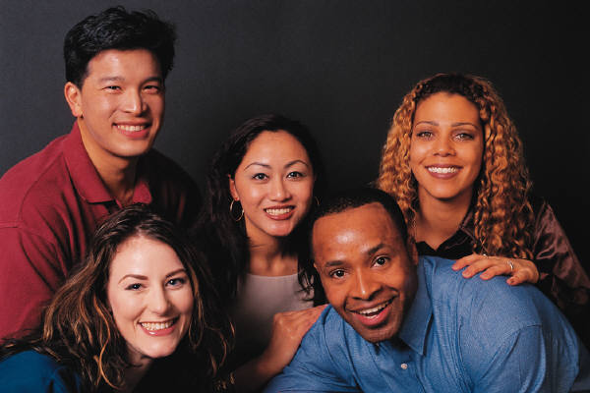

NOTES

SUnday | Monday | Tuesday | Wednesday | Thursday | Friday | Saturday
 | 1 | 2 | 3 | 4 | 5 | 6
7 | 8 | 9 | 10 | 11 | 12 | 13
14 | 15 | 16 | 17 | 18 | 19 | 20
21 | 22 | 23 | 24 | 25 | 26 | 27
28

DAD’S EVENTS | DATE

mom’s EVENTS | DATE

Maile’s Events | Date
2010
FEB

OUR FAMILY CALENDAR

TO DO
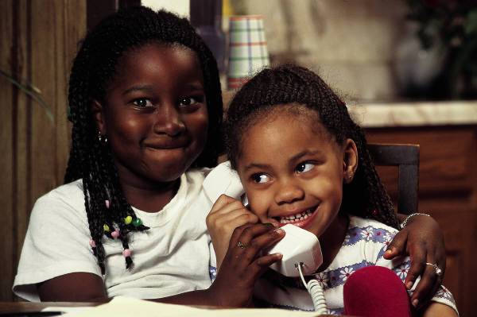

NOTES

SUnday | Monday | Tuesday | Wednesday | Thursday | Friday | Saturday
 | 1 | 2 | 3 | 4 | 5 | 6
7 | 8 | 9 | 10 | 11 | 12 | 13
14 | 15 | 16 | 17 | 18 | 19 | 20
21 | 22 | 23 | 24 | 25 | 26 | 27
28 | 29 | 30 | 31
DAD’S EVENTS | DATE
mom’s EVENTS | DATE
Maile’s Events | Date
2010
MAR

OUR FAMILY CALENDAR

TO DO
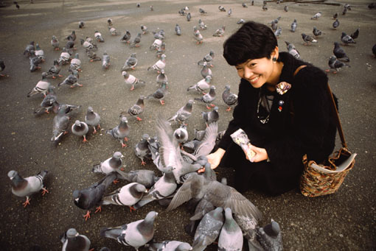

NOTES
NOTES

SUnday | Monday | Tuesday | Wednesday | Thursday | Friday | Saturday
 |  |  |  | 1 | 2 | 3
4 | 5 | 6 | 7 | 8 | 9 | 10
11 | 12 | 13 | 14 | 15 | 16 | 17
18 | 19 | 20 | 21 | 22 | 23 | 24
25 | 26 | 27 | 28 | 29 | 30
DAD’S EVENTS | DATE
mom’s EVENTS | DATE
Maile’s Events | Date
2010
APR

OUR FAMILY CALENDAR

TO DO


NOTES

SUnday | Monday | Tuesday | Wednesday | Thursday | Friday | Saturday
 |  |  |  |  |  | 1
2 | 3 | 4 | 5 | 6 | 7 | 8
9 | 10 | 11 | 12 | 13 | 14 | 15
16 | 17 | 18 | 19 | 20 | 21 | 22
23 | 24 | 25 | 26 | 27 | 28 | 29
30 | 31
DAD’S EVENTS | DATE
mom’s EVENTS | DATE
Maile’s Events | Date
2010
MAY

OUR FAMILY CALENDAR

TO DO


NOTES

SUnday | Monday | Tuesday | Wednesday | Thursday | Friday | Saturday
 |  | 1 | 2 | 3 | 4 | 5
6 | 7 | 8 | 9 | 10 | 11 | 12
13 | 14 | 15 | 16 | 17 | 18 | 19
20 | 21 | 22 | 23 | 24 | 25 | 26
27 | 28 | 29 | 30
DAD’S EVENTS | DATE
mom’s EVENTS | DATE
Maile’s Events | Date
2010
JUN

OUR FAMILY CALENDAR

TO DO


NOTES

SUnday | Monday | Tuesday | Wednesday | Thursday | Friday | Saturday
 |  |  |  | 1 | 2 | 3
4 | 5 | 6 | 7 | 8 | 9 | 10
11 | 12 | 13 | 14 | 15 | 16 | 17
18 | 19 | 20 | 21 | 22 | 23 | 24
25 | 26 | 27 | 28 | 29 | 30 | 31
DAD’S EVENTS | DATE
mom’s EVENTS | DATE
Maile’s Events | Date
2010
JUL

OUR FAMILY CALENDAR

TO DO


NOTES

SUnday | Monday | Tuesday | Wednesday | Thursday | Friday | Saturday
1 | 2 | 3 | 4 | 5 | 6 | 7
8 | 9 | 10 | 11 | 12 | 13 | 14
15 | 16 | 17 | 18 | 19 | 20 | 21
22 | 23 | 24 | 25 | 26 | 27 | 28
29 | 30 | 31
DAD’S EVENTS | DATE
mom’s EVENTS | DATE
Maile’s Events | Date
2010
AUG

OUR FAMILY CALENDAR

TO DO


NOTES

SUnday | Monday | Tuesday | Wednesday | Thursday | Friday | Saturday
 |  |  | 1 | 2 | 3 | 4
5 | 6 | 7 | 8 | 9 | 10 | 11
12 | 13 | 14 | 15 | 16 | 17 | 18
19 | 20 | 21 | 22 | 23 | 24 | 25
26 | 27 | 28 | 29 | 30
DAD’S EVENTS | DATE
mom’s EVENTS | DATE
Maile’s Events | Date
2010
SEPT
NOTES

OUR FAMILY CALENDAR

TO DO


NOTES

SUnday | Monday | Tuesday | Wednesday | Thursday | Friday | Saturday
 |  |  |  |  | 1 | 2
3 | 4 | 5 | 6 | 7 | 8 | 9
10 | 11 | 12 | 13 | 14 | 15 | 16
17 | 18 | 19 | 20 | 21 | 22 | 23
24 | 25 | 26 | 27 | 28 | 29 | 30
31
DAD’S EVENTS | DATE
mom’s EVENTS | DATE
Maile’s Events | Date
2010
OCT

OUR FAMILY CALENDAR

TO DO
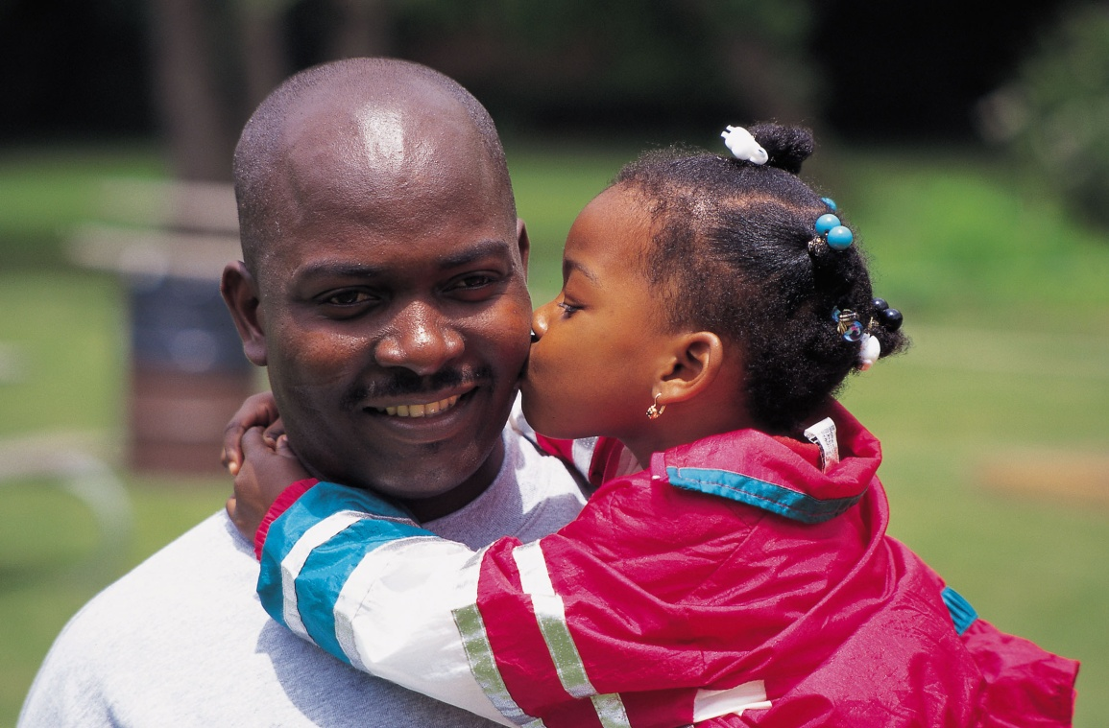

NOTES

SUnday | Monday | Tuesday | Wednesday | Thursday | Friday | Saturday
 | 1 | 2 | 3 | 4 | 5 | 6
7 | 8 | 9 | 10 | 11 | 12 | 13
14 | 15 | 16 | 17 | 18 | 19 | 20
21 | 22 | 23 | 24 | 25 | 26 | 27
28 | 29 | 30
DAD’S EVENTS | DATE
mom’s EVENTS | DATE
Maile’s Events | Date
2010
NOV

OUR FAMILY CALENDAR

TO DO


NOTES

SUnday | Monday | Tuesday | Wednesday | Thursday | Friday | Saturday
 |  |  | 1 | 2 | 3 | 4
5 | 6 | 7 | 8 | 9 | 10 | 11
12 | 13 | 14 | 15 | 16 | 17 | 18
19 | 20 | 21 | 22 | 23 | 24 | 25
26 | 27 | 28 | 29 | 30 | 31
DAD’S EVENTS | DATE
mom’s EVENTS | DATE
Maile’s Events | Date
2010
DEC

OUR FAMILY CALENDAR

TO DO


NOTES

